***SELECT STATEMENT***

**Query**: ***Identify the sales amount that are greater than $1000 and greater or equal January 1st 2002.***

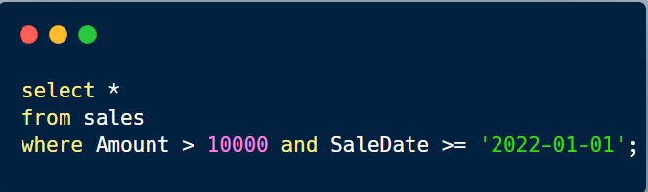 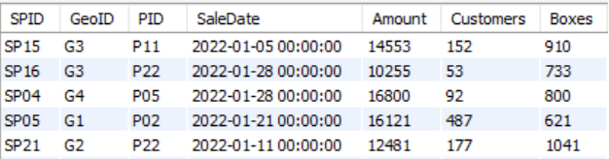

***JOINS***

**Query**: ***Which product has the highest sales revenue?***

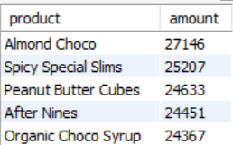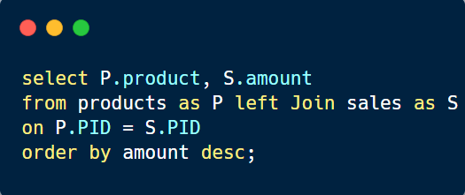

Answer: Almond Choco

***CTE (Common Table Expression): Temporary Query***

**Query**: ***Compare the total sales amounts of Gigi Bohling and Camilla Castle and determine who performed better.***

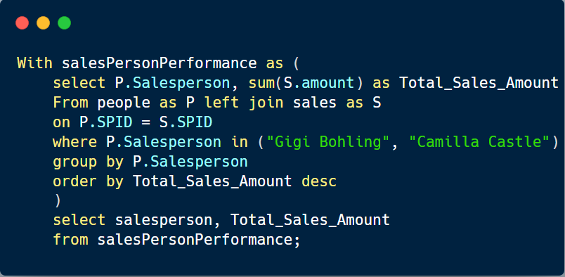 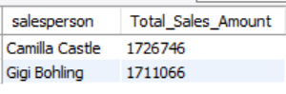

Answer: Camilla Castle performed better.

***Case When Statement***

**Query**: ***Define the amount category based on the specific criteria listed below.***

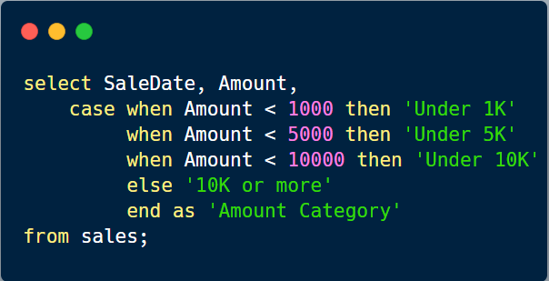 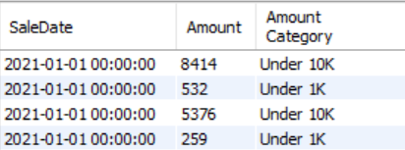

***Windows Functions***

**Query**: ***Identify the top products based on the total sales Amount***

